|  |  |
| --- | --- |
| **Exp No: 3**  **Date:** | **Write a Servlet program that prints "Hello, World!" when accessed through a browser.** |

**AIM:**

To create a Servlet program that prints "Hello, World!" when accessed through a browser.

**PROGRAM:**

**Hellowolrd.jsp**

<%@ page contentType=*"text/html;charset=UTF-8"* language=*"java"* %>

<!DOCTYPE html>

<html>

<head>

<title>Hello World JSP</title>

</head>

<body>

<h1>Hello, World!</h1>

</body>

</html>

**OUTPUT:**

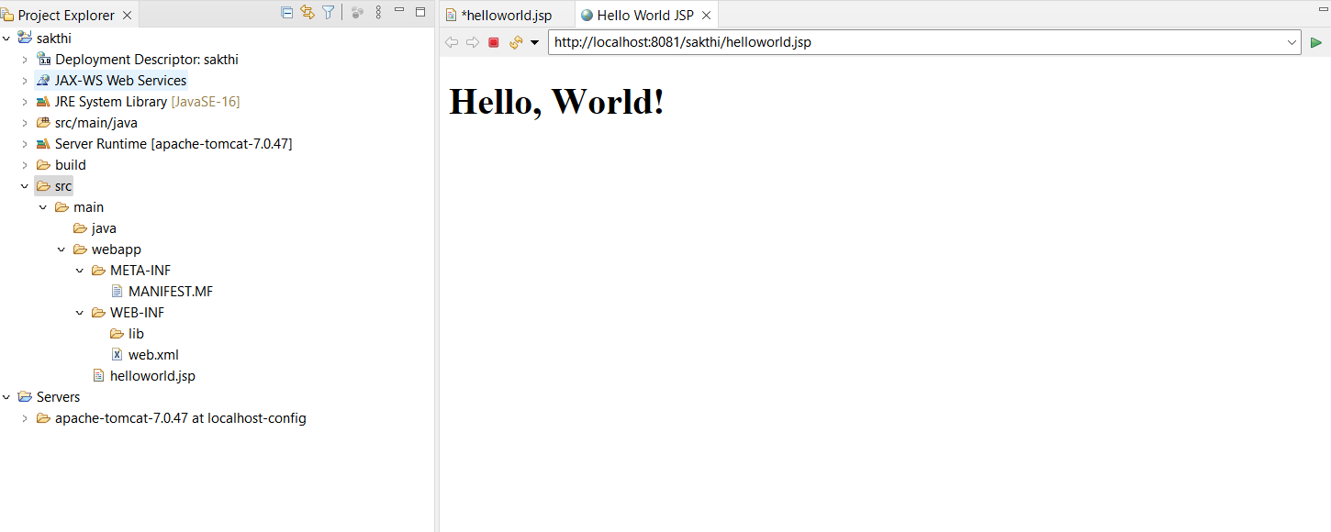

**RESULT :**Thus the create a web form that accepts a user’s name and age and to write a servlet to process the form data and display it back on the browser has been implemented and verified successfully